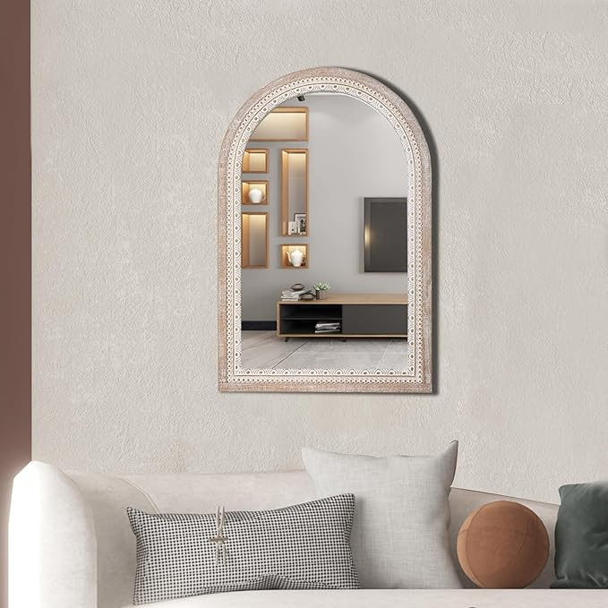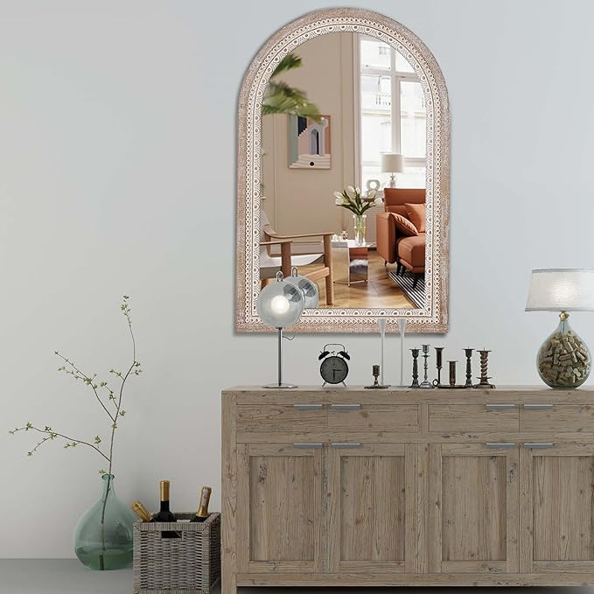

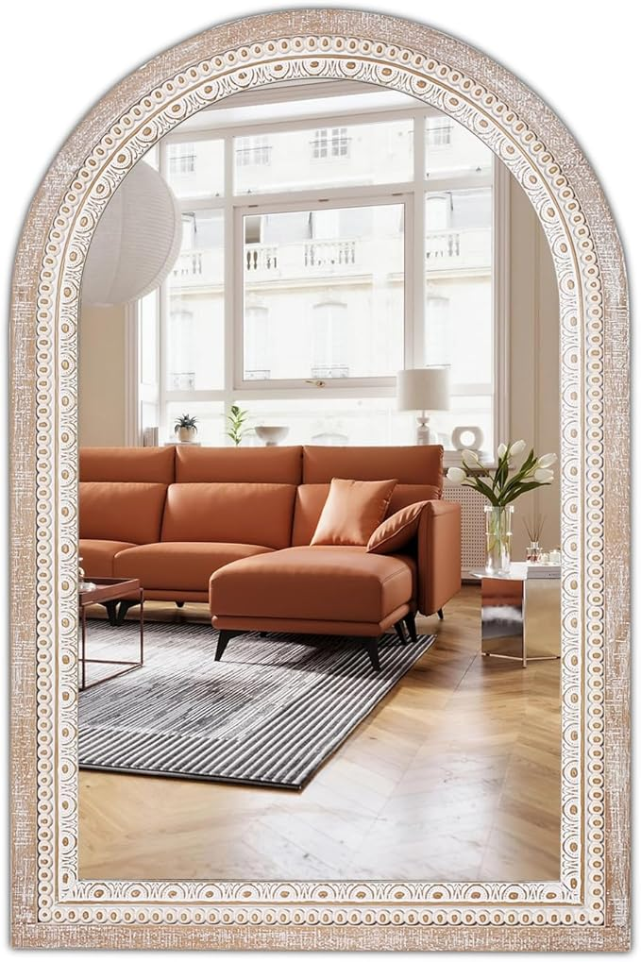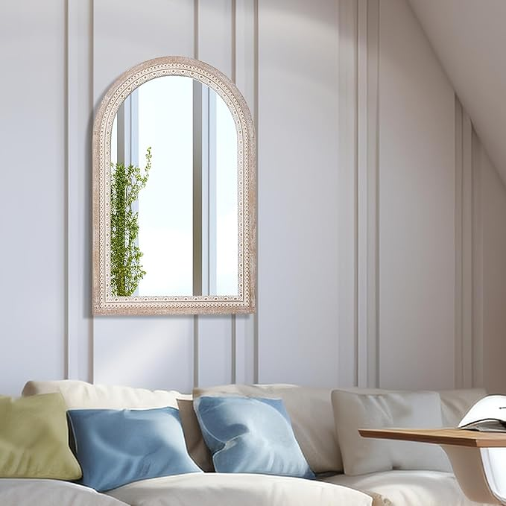

36x24'' Farmhouse Arched Decorative Wall Mirror, Farmhouse Wooden Mirrors with Beaded for Living Room, Hallway, Bathroom, Entryway - Vertical/Horizontal

**PRODUCT DESCRIPTION :**

|  |  |
| --- | --- |
| **Brand** | Reflinto |
| **Room Type** | Living Room |
| **Shape** | 36x24'' Arched |
| **Product Dimensions** | 36"L x 24.3"W |
| **Frame Material** | Wood |

**About this item**

* Timeless Elegance: Add a touch of timeless elegance to your home with our 36x24 wooden arched mirror. Its classic design and graceful curves make it a captivating addition to any room.
* Premium Craftsmanship: Crafted with precision, our living room decorative mirrors features a sturdy wooden frame and a high-definition reflective surface, ensuring durability and providing clear, distortion-free reflections.
* Versatile Placement: Perfect for entryways, living rooms, bedrooms, or bathroom vanity mirror, this rustic mirror complements various interior styles and serves as a stylish focal point that enhances the overall ambiance of your space.
* Enhance Light and Space: The reflective surface of the wall mirrors decorative helps to brighten the room by reflecting natural and artificial light, creating an illusion of openness and adding depth to your living areas.
* Easy Installation, Satisfaction Guaranteed: With included mounting hardware and simple instructions, installing this hanging mirror is hassle-free. We are committed to your satisfaction and offer a guarantee, ensuring that you'll love the quality and beauty of our 36x24 wooden arched mirror.